5th Edition

National championship

Championship rules
Ref. 09-2021

Contents:
1 Introduction 5
1.1 Championship regulatory authority 5
1.2 Phases of the competition 5
1.2.1 Phase 1: Technical and creative section 5
1.2.2 Phase 2: Dynamic tests 5
1.3 Breakdown of the Euskelec championship 2021-2022 6
1.3.1 Euskelec 2021-2022 prizes 6
1.3.2 Communication prize 7
1.3.3 Innovation prize 7
1.3.4 Technical design prize 7
1.3.5 Speed prize 7
1.3.6 Endurance prize 7
1.3.7 Euskelec prize 8
1.3.8 Sustainability prize 8
1.3.9 Aesthetic design prize 8
1.3.10 Rookie team prize 8
1.3.11 Scoring system 9
2 Administrative rules 10
2.1 Participants 10
2.1.1 Teams 10
2.1.2 Driver 11
2.1.3 Cancellations and substitutions 11
2.1.4 Guest teams 11
2.2 Team sponsors 11
2.3 Championship regulatory framework 12
2.3.1 Compliance with the rules 12
2.3.2 Right to complain 12
3 General rules 13
3.1 Phase 1: Technical-creative section 13
3.2 Phase 2: Dynamic tests 13
3.2.1 Dynamic test rules 14
3.2.2 Preparation and start of the trial 14
3.2.3 Flags 14
3.2.4 Braking 15
3.2.5 Acceleration 15
3.2.6 Slalom 16
3.2.7 Classification 16
3.2.8 Endurance 17
3.2.9 Dynamic test scores 19
3.3 Penalties 19
3.3.1 Phase 1 penalties: 19
3.3.2 Phase 2 penalties: 20
4 Technical rules 21
4.1 General aspects of the vehicle 21
4.1.1 Power kit 21
4.1.2 Dimensions 21
4.1.3 Weight 23
4.1.4 Visibility 23
4.1.5 Equipment for the drivers 23
4.2 Structural elements of the vehicle 23
4.2.1 Chassis design 23
4.2.2 Roll bar 24
4.2.3 Materials 26
4.2.4 Driver’s compartment 26
4.3 Steering, traction and brakes 27
4.3.1 Steering 27
4.3.2 Wheels 27
4.3.3 Motor and transmission 28
4.3.4 Accelerator 29
4.3.5 Brakes 29
4.4 Electrical system 29
4.4.1 Specification of the electrical components 29
4.4.2 Electric accumulators 31
4.4.3 Electrical protective devices 31
4.5 Bodywork 32
4.5.1 Design 32
4.5.2 Team numbers 33
4.5.3 Identification 34
4.5.4 Advertising 34
4.5.5 Ventilation of the cockpit 34
4.6 Safety equipment 34
4.6.1 Seat belt 34
4.6.2 Evacuation of the driver 35
4.6.3 Towing points 35
4.6.4 Insulation of the traction system 36
4.6.5 Horn 36
4.6.6 Speedometer 36
4.6.7 Emergency stop 36
4.6.8 Maintenance stop 37
4.6.9 Position and brake lights 37
4.7 Vehicle verification 38
4.7.1 Verification of driver evacuation 39
4.7.2 Verification of braking 39
4.7.3 Verification of the turning radius 40
4.7.4 Right of inspection 40
4.7.5 Rectification of problems or adjustments 40
5 Rules of the event 41
5.1 Event guide 41
5.2 Complaint form 41
5.3 Enquiry form 41

EUSKELEC ELECTRIC VEHICLE CHAMPIONSHIP RULES AND GUIDELINES

(5th EDITION)

Introduction

Championship regulatory authority
The championship rules have been validated by the organising committee, which is made up of a representative from each of the promoters of this championship:
- Tknika
- Alterity
This committee is the regulatory authority of the championship and as such will appoint a Technical Management Team for the championship.

Phases of the competition
All the projects and prototypes presented by the participants will be evaluated in different tests, divided into two phases:
- Phase 1: technical and creative section, which will be carried out starting in October and will continue throughout the 2021-2022 academic year.
- Phase 2: Dynamic tests, to be carried out between May and June 2022.
The championship consists of different tests that may or not be used to score points for the teams depending on their objective:
Tests | Excluded | Scoring
Phase 1: Technical and creative section | Yes | Yes
Technical verification | Yes | No
Phase 2: Dynamic tests | Yes | Yes
Table 1: Tests to pass

Phase 1: Technical and creative section
Phase 1 is a demonstration phase in which the teams must show, explain and justify the design of the prototype produced and the proposed project for its manufacture.
The rules and information regarding phase 1 of the championship are described in point 3.1 of these rules.

Phase 2: Dynamic tests
The rules and information regarding phase 2 of the championship are described in point 3.2 of these rules.

Breakdown of the Euskelec championship 2021-2022

Euskelec 2021-2022 prizes

 | Phase 1:  Technical and creative section | Challenges | Structure of the team
 |  |  | Analysis of the competition
 |  |  | Communication
 |  |  | Concept
 |  |  | Electrical diagram
 |  |  | Innovation
 |  |  | Report
 |  |  | Presentation
 |  | Communication prize
 |  | Innovation prize
 |  | Technical design prize
 | Euskelec 2021-2022 Phase 1 First prize
 | Phase 2:  Dynamic tests | Tests | Acceleration
 |  |  | Slalom
 |  |  | Braking
 |  |  | Endurance
 |  |  | Fast lap
 |  | Speed prize
 |  | Endurance prize
 |  | Euskelec prize
 |  | Sustainability prize
 |  | Aesthetic design prize
Rookie team prize
Euskelec 2021-2022 1st, 2nd and 3rd prizes

Communication prize
This will be presented to the team that is considered to have carried out the best communication and publicity campaign. The methods used by the teams to promote their project, their effectiveness and their degree of innovation will be assessed.

Innovation prize
The best innovation will receive 20 extra points. All aspects of the innovation presented in Challenge 6 (Innovation), Challenge 7 (Report) and Challenge 8 (Presentation) will be assessed.
The project must include an innovation that provides some degree of novelty related to any aspect of participation in the championship. Innovations of any kind will be accepted, whether in manufacturing methods, materials, work methodologies, team organisation, project management, marketing methods, policy implementation or any other measure that adds value to the project carried out.
This section aims to assess:
- The creativity and originality of the innovation.
- The added value and its potential.
- The capacity for implementation.
During the presentation of phase 1 (Challenge 8), the panel of judges will assess the innovations of the teams and the most highly rated innovation will be awarded the prize.

Technical design prize
For the awarding of this prize, all aspects of the design presented in Challenge 4 (Concept), Challenge 7 (Report) and Challenge 8 (Presentation) will be assessed.
An assessment will be made of how the teams have decided to approach the manufacture of the prototype for the championship and how they specify its manufacture at a theoretical level. The project report will describe the proposed structural, cycle and electrical parts and what strategies will be carried out in order to be able to build or assemble it.
The design must take into account the team’s resources, the construction methodologies, the time available, and all the aspects that the team deems appropriate to highlight in relation to the production of the prototype.
One of the competition sponsors, from the automotive or mobility sector, will award this prize and the team will receive 30 extra points.

Speed prize
This will be awarded to the team that obtains the highest score by adding together the scores of the braking, acceleration and slalom trials.

Endurance prize
This will be awarded to the team that obtains the highest score in the endurance trial without taking into account the score obtained for the fastest lap.

Euskelec prize
This will be awarded to the team that it is considered best represents the values of the competition: ethics, sportsmanship, teamwork, attitude and initiative, etc. Teams will be assessed both in phase 1 and phase 2 and in the day-to-day performance in the competition in general.

Sustainability prize
This will be awarded to the most environmentally aware team. A competition sponsor will choose the winner taking into account the presentations in phase 1 and what was seen on the day of the competition during phase 2. The use of recycled and/or recyclable materials and the measures taken to minimise the environmental impact throughout the life cycle of the single-seater vehicle will be assessed.

Aesthetic design prize
This will be awarded to the team with the best designed, most impressive and professional aesthetics. The winning team will be chosen via an online vote during a period starting a number of days prior to phase 2 and during phase 2.

Rookie team prize
This will be awarded to the rookie team that has earned the most points at the end of the competition. In the event that this team is also the winner of the competition, the award will go to the second debuting team that has scored the most points.

Scoring system
The scores of the different tests will be added together with a maximum score defined in the following table:

 | Technical and creative section | Challenges | Structure of the team | 15
 |  |  | Benchmarking | 25
 |  |  | Communication | 25
 |  |  | Concept | 45
 |  |  | Electrical diagram | 40
 |  |  | Innovation | 75
 |  |  | Report | 140
 |  |  | Presentation | 75
 |  | 1st place innovation |  | 30
 |  | 1st place technical design |  | 30
 | Total phase 1: | 500
 | Dynamic tests: | Acceleration |  | 90
 |  | Slalom |  | 120
 |  | Braking |  | 70
 |  | Endurance |  | 200
 |  | Fast lap |  | 20
 | Total phase 2: | 500
TOTAL: | 1000

Table 2: Summary of score
Each of these tests will be evaluated and scored in such a way that the groups of tests in each phase will be added up, giving the total points for each phase. For the final score of the entire championship, the points of the two phases will be added together, giving the total score for each team in the championship.

Administrative rules

Participants
The 5th edition of Euskelec will be open to the participation of any vocational training centre, which will be provided with the basic motor elements of the vehicle (motor, motor controller and batteries), and based on these components the students will have to develop a vehicle to satisfy the requirements of the technical rules of the championship.

Teams
Each team will represent a training centre that provides intermediate, advanced and/or basic professional training. The teams will be made up of a minimum of 5 members. There is no maximum limit to the number of team members that can participate in the construction of the single-seater vehicle. However, the competition reserves the right to limit the number of people who can access the phase 1 event or the reserved areas of the phase 2 event (boxes, circuit, etc.).
There is also the possibility of creating a team in which members from more than one centre participate as long as the organisation is notified in advance and gives its approval. From that moment on, the team will be considered represented by these two centres together.
Any participant can only be registered in a single team and all team members must be enrolled in and/or belong to the training centre during the academic year in which the competition is held. In the case of ex-students, only those who have studied at the centre the previous year will be admitted.
Each team must designate one or two teaching advisers, who will be recognised as tutor and co-tutor of the team, as well as a team leader who, together with the chosen tutors, will represent the team in communication with the organisation and will be the interlocutors with it. Under no circumstances will the tutors count as members of the team when counting the number of people registered in each team.
During the entire competition, the tutors will play the role of advisor and/or coordinator, being able to advise the teams on any point arising in the project. Under no circumstances can the tutors design any part of the vehicle or participate in the development of any type of documentation or presentation. The tutors cannot assemble or manufacture any component of the vehicle, or repair or assist in repairs during the event. Therefore, the tutors cannot manipulate the vehicle under any circumstances.

Driver
Each team must present a driver who will be responsible for driving the vehicle during the dynamic tests in phase 2 of the championship. In order to prevent teams from having advantages, and given that the objective of the championship is to evaluate the vehicle and the preparation work by the team, the following conditions have been established:
- The driver must be a member of the team and therefore is counted as one of the group of registered members.
- The driver will have the same rights and obligations as any other member of the team without exception.
- The driver must be at least 16 years old on the day of the championship event.
The team can, but is not obliged to, appoint a substitute driver in order to replace the main driver in the event that he or she cannot participate in the tests of phase 2 of the event for justified reasons. However, during practice and stage 2 testing, only a single driver is allowed to drive in the event trials. Furthermore, only the driver can remain in the vehicle during the trials.

Cancellations and substitutions
Until 15 January 2022, it will be possible to modify the composition of the team, either by increasing the number of team members, replacing some students with others or removing members. As of that date, modifications of the members will only be accepted for justified reasons.
All changes to the participating students must be communicated promptly to the organisation by the teaching advisor and/or by the person in charge of the team, by email to admin@euskelec.eus or by telephone.

Guest teams
The organisation reserves the right to invite teams that do not meet any of the requirements to participate, despite the fact that they will have to comply with and abide by the rest of the rules.

Team sponsors
Team sponsors are allowed access to the areas reserved for the team as long as they do not carry out advertising or promotion activity not authorised by the organising committee.

The team or the sponsor may carry out any commercial activity and/or sale of objects within the framework of the competition, as long as it is explicitly authorised by the organising committee and is carried out within the area designated for that purpose.

Championship regulatory framework
These rules for the 5th Euskelec championship 2021-2022 have been prepared solely for carrying out this championship and will not be applicable outside the framework of this competition.

Compliance with the rules
The teams participating in the championship are responsible for being familiar with the rules and will agree on their implementation, interpretation or procedures deriving from their application. Acting contrary to the intention of the rules will be considered a breach of the rules.
During the competition, all teams are committed to following the instructions of the organisation staff.
The organisation has the right to sanction all those teams that fail to comply with any aspect of these rules or the established timetables with the appropriate penalty, as established in section 3.3 of these rules, as well as those teams that demonstrate unsportsmanlike behaviour or could endanger people or facilities.

Right to complain
Any participating team can submit complaints or suggestions. The organising committee will promptly assess any query, non-compliance or sanction presented using the agreed method.
A team can complain in the case of any disagreement with any action taken by the organisation, either in the appraisal of the championship or any other action that they consider to have been damaging to their team.
Any team can challenge another participating team in the event of observing any breach of the championship rules or due to inappropriate behaviour.
All complaints and challenges must be submitted to the organisation following the presentation format provided in section 5.2 of these rules, indicating the point in the rules that is considered to have been breached, together with the necessary evidence for its verification. Complaints or challenges prior to the final event may be sent scanned or with a digital signature by email to admin@euskelec.eus and they will be evaluated and a response provided within a maximum time of 10 business days from receipt of the communication, while complaints or objections communicated during the event must be submitted in writing to the organisation staff and will be answered as soon as possible on the same day.

General rules
The Euskelec championship consists of two phases:
- Phase 1: Technical and creative part
  - Structure of the team
  - Benchmarking (Analysis of the competition)
  - Communication
  - Concept
  - Electrical diagram
  - Innovation
  - Report
  - Presentation
- Technical verification
- Phase 2: Dynamic tests
  - Acceleration
  - Slalom
  - Braking
  - Classification
  - Endurance
The scoring of each test is defined in point 1.3.11 of these rules.

Phase 1: Technical-creative section
Based on the championship calendar, the challenges of phase 1 must be submitted to the organisation in digital format within the deadlines established in the document “Euskelec Challenges 2022”.
As explained in section 3.3.1 of these rules, teams that submit challenges after the deadline set by the organisation will be penalised. Points are scored for the challenges and they are mandatory.
A technical panel set up for the competition will assess the challenges and projects based on the requirements and objectives established for each challenge.

Phase 2: Dynamic tests
The competition involves five dynamic tests:
- Braking trial
- Acceleration trial
- Slalom trial
- Classification trial
- Endurance trial

Dynamic test rules
To carry out the different dynamic tests, both the drivers and the teams have to follow the guidelines of the race management and the organisation of the event at all times.
All the championship trials have to be carried out with the battery provided by the organisation. During the course of the championship, recharging the battery will be strictly prohibited except by express authorisation of the organisation. It is recommended that the team bring the battery 100% charged. The detection or observation of the recharging of batteries, outside the time allowed by the organisation, will be regarded as a very serious infraction and the team will be expelled from phase 2 of the championship.
During the course of the trials, the teams must remain in the box area, behind the line of the pit lane, and cannot enter the circuit at any time. In the event of a stoppage or breakdown, the organisation may authorise entry to the circuit by the members of the team where this is necessary to assist the vehicle in question, always following the indications of the race management.
The stewards are in charge of determining whether the performance of each trial by the different teams has been valid. In the event that a trial is invalid for reasons beyond the control of the teams or the organisation, the stewards will reserve the right to evaluate the situation and allow the trial to be repeated according to the requirements and objectives set in each challenge.

Preparation and start of the trial
Before starting any trial, the teams must remain in their respective boxes. When the organisation stewards indicate the start of a trial, the drivers must get into the vehicles and drive around the circuit, starting from the pit lane, to their corresponding position on the starting grid of the respective trial, according to the pre-established order for the championship. The drivers will have to wait their turn in line. When the steward indicates, the driver will start the trial. After completing the trial in progress, the driver must join the main circuit and finish the remaining section of the circuit from the start of the trial to the entrance of the pit lane, parking the vehicle in the box again. In the event of not complying with the rules, the team may be penalised according to the penalties established in these rules.

Flags
While the single-seater vehicle is on the track, the stewards and the organisation will use flags to communicate with the drivers. The meaning of the message based on the colour of the flag is explained below:

Flag | Meaning
 | Track clear
 | Caution, overtaking prohibited
 | Track closed, go to the pits slowly
 | Enter the pits due to a mechanical problem, reprimand due to behaviour or penalty
 | Let the car behind overtake
 | End of race, return to the pits

Braking
The objective of the teams in this trial is to be able to brake and stop the vehicle in the shortest possible distance. The driver who stops the shortest distance from the start of the braking line will be the winner of the trial and the other teams will be classified based on their proximity to the winning result. In the event that there are teams that obtain the same result, the teams will obtain the same score corresponding to the highest position that the best result would have occupied. In this case, the scores for the lower positions of the tied teams will not be awarded.
This trial begins with the acceleration of the vehicle to a minimum speed of 25 km/h and the driver must begin to brake when the braking line, marked by two cones, is crossed by the front wheels. In the event of crossing the braking start line at a speed lower than the minimum speed or initiating the act of braking before crossing the line, the team’s score in that braking round will be null.

Acceleration
The acceleration trial consists of travelling a distance of 60 metres in the shortest possible time. The driver who crosses the finish line in the shortest time will be the winner of the event; the other participants will be classified by proximity to the winning result. In the event that there are teams that obtain the same result, the teams will obtain the same score corresponding to the highest position that the best result would have occupied. In this case, the scores for the lower positions of the tied teams will not be awarded.
To carry out this trial, the driver will have a 6 m wide lane in which to drive in a straight line. The driver cannot go beyond the area established for the trial.
The driver can accelerate whenever they want once they have been shown the green flag by the steward. The trial begins when the driver begins to move and ends when the driver crosses the finish line, thus establishing the time obtained by the competing team.

Slalom
The slalom trial aims to measure the dynamics of the vehicle and therefore the ability to change direction in an agile way. The driver who crosses the finish line in the shortest time, correctly completing the circuit marked out, will be the winner of the trial. The other drivers will be classified by proximity to the winner’s result. In the event that there are teams that obtain the same result, the teams will obtain the same score corresponding to the highest position that the best result would have occupied. In this case, the scores for the lower positions of the tied teams will not be awarded.
The trial begins with the signal from the steward, after which the driver must negotiate the circuit marked with cones in the shortest possible time. The knocking over of cones will be penalised with 5 seconds for each cone that is knocked down. This penalty will only apply for the classification of this trial. The circuit, which will be designed within the constraints of the final location for the dynamic tests, may be made up of straights of no more than 80 m, constant radius curves of up to 50 m in diameter, slaloms defined by cones placed in a straight line 8 to 12 m apart, chicanes, descending radius curves, height changes, etc. The minimum width of the track is 3 m and the curve radii will in no case be less than 3.5 m.

Classification
The classification is a non-scoring trial that will determine the starting position in the final endurance trial. It is a trial that involves making laps of the circuit simulating the different situations of the endurance trial so that the teams can test their vehicles.
It consists of completing these laps of the circuit with the aim of obtaining the best individual time possible. To establish the starting order in the endurance trial, the fastest laps in the classification will be recorded and the teams will be sorted in order of times for the fastest complete lap, that is, the team with the fastest complete lap in the ranking will be first and so on. There will be a fixed time of 20 minutes to go around the circuit. The stewards will indicate the end of this time with chequered flags. The current lap will be the last valid lap and will be counted in the trial. Teams must complete a minimum of 3 full laps of the circuit in order to participate in the endurance trial. If the participants do not complete 3 full laps in the classification, they will not be penalised but they will not be able to participate in the endurance trial.
During the course of the trial, the drivers are obliged to allow any pursuing vehicle to overtake them if it catches up with them and is therefore travelling at a higher speed. To overtake a vehicle, the pursued driver must be warned by a beep, so that they can check that the pursuing driver is in their slipstream. The pursued driver will not modify their course or speed to facilitate the overtaking of the pursuing driver. The pursuing driver must overtake cleanly and without cutting across the path of the driver in front, who in turn must not prevent the driver behind from overtaking.
If a driver is caught up by another and prevents them from overtaking, thus creating dangerous situations, they will be penalised with a serious penalty and will be forced to perform a “Stop&Go” during the endurance trial.
The stewards will indicate the end of the trial time with chequered flags. At this moment in time, the drivers must finish the current lap and head towards the pits to park their vehicles.

Endurance
The endurance trial aims to test the autonomy and efficiency of the vehicles. For this purpose, the teams must carry out the maximum possible number of laps of the circuit in a time of 60 minutes.
The winner of this trial will be the driver who covers the greatest distance in the stipulated time. In the event that two teams complete the same number of laps, the team that has driven the greatest distance in the last lap in progress will win. The other teams will be classified by proximity to the winning result. The trial will start with the waiting cars at a safe distance and with the green flag signal from the track steward.
During the course of the trial, the drivers are obliged to allow any pursuing vehicle to overtake them if it catches up with them and is therefore travelling at a higher speed. To overtake a vehicle, the pursued driver must be warned by a beep, so that they can check that the pursuing driver is in their slipstream. The pursued driver will not modify their course or speed to facilitate the overtaking of the pursuing driver. The pursuing driver must overtake cleanly and without cutting across the path of the driver in front, who in turn must not prevent the driver behind from overtaking.
If a driver is caught up by another and prevents them from overtaking or overtakes another vehicle in the no-overtaking zones, thus creating dangerous situations, they will be penalised with a serious penalty and will be forced to perform a “Stop&Go” during the trial.
During the course of this trial, the times of the best laps of the teams will be recorded, rewarding the team that has completed a full lap in the shortest time with an extra 20 points added to the score obtained for the position in the trial. This extra score is added to the total score of the championship, but under no circumstances will it change the position obtained in the endurance trial.
The stewards will signal the end of the trial with chequered flags, at which point the drivers must brake and bring the vehicles to a stop. The organisation will count the distance travelled by each of the participants and will once again indicate by means of a chequered flag the end of the current lap so that the drivers head to the pits to park their vehicles. This last lap completed after the chequered flag will not count, either for the total number of laps of the trial or for the total distance travelled in the trial. Only the distance completed up to the moment at which the end of the trial is indicated with the first wave of the chequered flag will count.
The endurance trial circuit has the same characteristics as the Slalom circuit but will not necessarily be exactly the same.

Dynamic test scores
In all phase 2 trials of the championship, the criteria in the table below will be used for the awarding of points.
Position | Points | Position | Points | Position | Points | Position | Points | Position | Points
1st | M | 6th | 0.57*M | 11th | 0.35*M | 16th | 0.23*M | 21st | 0.16*M
2nd | 0.88*M | 7th | 0.52*M | 12th | 0.32*M | 17th | 0.22*M | 22nd | 0.15*M
3rd | 0.78*M | 8th | 0.47*M | 13th | 0.28*M | 18th | 0.2*M | 23rd | 0.14*M
4th | 0.7*M | 9th | 0.42*M | 14th | 0.27*M | 19th | 0.18*M | 24th | 0.13*M
5th | 0.63*M | 10th | 0.38*M | 15th | 0.25*M | 20th | 0.17*M | 25th | 0.12*M

Where M is the maximum score for each test.

Penalties

Phase 1 penalties:
The deadlines stipulated by the organisation of the championship must be met. In the event of delays in the submission of the stipulated challenges the following penalties will be applied:
The delay in the completion of each challenge in an administrative sense will lead to a penalty of 5% of the total score of the challenge for each day of delay with a maximum of 50% of the score. In other words, when a team submits a completed challenge within the stipulated period, they can achieve a maximum score of 100%, but if, for example, the submission is delayed for 2 days, they can only achieve 90% of the maximum score for the challenge and, from the tenth day of delay, they can only achieve 50% of the maximum score.
The penalties accumulated in phase 1 will be applied to the final score of phase 1 and will be applied at the end of this phase according to the distribution of scores defined in section 1.3.11. Penalties cannot be transferred from phase 1 to phase 2 or vice versa.
To participate in phase 2 of the championship, participation in and submission of challenges 7 Report and 8 Presentation is mandatory, and the team will not be able to continue in the championship until submission of the outstanding challenge, being penalised appropriately for the delay in its submission as specified above.
The submissions of the challenges are complete and definitive, and will be evaluated for the assigning of the final score.

Phase 2 penalties:
The criteria to be evaluated in each test are stipulated in each point of the rules. Failure to respect the rules or meet the minimum requirements demanded in any trial in the competition will be grounds for sanction based on the following list:
A. Serious: the team will be sanctioned and a penalty will be applied in which 150 points will be subtracted from the total for the competition. Non-respectful conduct in relation to any person, equipment or furniture and non-compliance with any point in the technical rules are considered serious sanctions.
B. Very serious: the team will be sanctioned with expulsion from the championship. Very serious sanctions are considered all those related to the safety of any person or persons, the modification of any item provided by the organisation and unsportsmanlike conduct.
In the event that a team is sanctioned repeatedly, three serious sanctions will be equivalent to a very serious sanction and therefore to expulsion from the competition without the option of repayment of the registration fee.
The competition judges will apply the corresponding penalties based on the criteria established in these rules objectively, based on the competition tests and rules.

Technical rules

For the design of the vehicle, its construction and the planning of the championship, the teams participating in Euskelec must use the material supplied by the organisation as the basis for traction.
This material will have to be mounted on a chassis designed and built entirely by each team.

General aspects of the vehicle
Each team will have to design and manufacture the chassis of a four-wheeled vehicle with a driver’s compartment that will be wide and long enough to accommodate a driver of at least 1.70 m in height and 65 kg in weight as a minimum. However, the driver only needs to meet the conditions established in point 2.1.2 of the rules in order to act as a driver.
It is mandatory for the teams to use the components provided by the organisation as a basis for manufacturing the power kit.

Power kit
The components that make up the power kit provided by the organisation are:
- EUS21 three-phase permanent magnet motor
- Guilera EUS21 motor controller
- Alterity EUS20 lithium battery
- EUS20 battery charger
- EUS20 drive contactor
- EUS20 complete accelerator pedal
- Alterity EUS20 electrical connector harness manufacturing kit
- EUS20 display indicator and display wiring
- EUS20 manual maintenance switch
These components cannot be modified under any circumstances. The organisation has the right to examine, weigh and/or seal any or all of the components of the power kit at any time during the championship in order to identify any modification to these. In case of manipulation or modification of the components of the kit, the team that has carried out this action will be sanctioned with a very serious penalty and will therefore be expelled from the championship.
The organisation can request the handing over of any part of the kit for the review, update and modification of any component at any time.

Dimensions
The vehicles will have some measurements that can be decided by the participants and others that are critical measurements stipulated by the organisation. The critical measurements are those set out below and must be adhered to:
- Length between 2200 and 2500 mm, measured horizontally between the imaginary vertical lines that pass through the two furthest extremes in the profile of the vehicle.
- Width between 1000 and 1200 mm, measured from the outer points of the wheel of the widest axle.
- Minimum wheelbase of 900 mm.
- Minimum axle track of 500 mm.
- Maximum height of 1200 mm, from the ground to the highest point of the vehicle without taking into account the roll bar.
- Minimum distance from the ground to the lowest point of the single-seater vehicle of 70 mm.
- Minimum distance from the most forward point of the chassis (structural) to the closest point of the front wheels of 50 mm, measured parallel to the longitudinal axis of the vehicle.
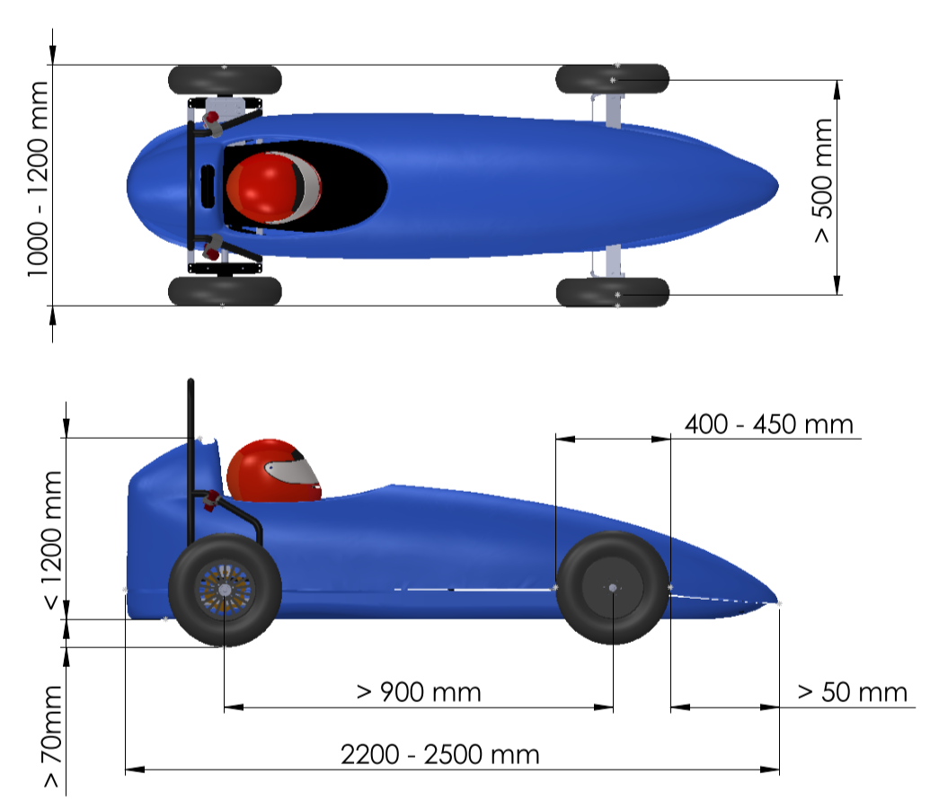

Weight
The vehicles must have a minimum weight of 140 kg and a maximum of 210 kg in running conditions. The weight of the vehicle will be measured with the driver inside, with the same clothing that they will use for the trials, including helmet and gloves. Weighing will be done with four automotive scales.
In the event that ballast is needed to reach the minimum weight, this must be placed inside the vehicle and out of reach of the driver, so that it does not interfere with the driver’s ability to drive and is not dangerous for them. The ballast must be properly secured to the chassis of the vehicle. This can be bolted or clamped, among other forms of anchoring. Once this ballast has been fitted, the technical manager of the championship will seal the component and it may not be removed or modified at any time during the course of the championship.

Visibility
The driver must have an arc of visibility with a minimum amplitude of 180°.
The vehicle must be equipped with two rear-view mirrors, one on each side of the vehicle in a symmetrical position. The position of the mirrors must be such that the driver has a clear view of them, without having to change the driving position, and they must allow the driver to have an unobstructed view to the rear.

Equipment for the drivers
It is mandatory for the driver to wear an approved full-face protective helmet (for either a motorcycle or a car). If the helmet does not have a visor, goggles must be worn.
The driver must use a full one-piece race suit approved for competition and footwear that covers the foot completely. The race suit should be fireproof and if it is not the driver must wear fireproof underwear. At least one of the two items must meet one of the following certifications:
-FIA 8856-2000
-FIA 8856-2018
They must also wear a fireproof balaclava. The use of gloves is mandatory for the driver, and the use of cut-off gloves that leave the fingers exposed is prohibited.

Structural elements of the vehicle

Chassis design
The chassis design must be a self-produced prototype. It will not be permitted to completely reuse the chassis of previous editions except for justified reasons. The team must at least remanufacture the chassis or introduce some improvement based on the experience of the previous edition. Changes to the chassis will be described in the concept submission.
There are no limitations on the type of chassis design, as long as (for safety reasons) the driver’s head, in the normal driving position, is behind his/her torso and legs.
The chassis must provide protection to the driver in the event of an impact from any direction. Any bar that the driver may strike in the event of an accident must be padded with rubber, foam or similar at least 10 mm thick. In this way the driver must not be able to collide with any surface that is not sufficiently padded and that does not absorb part of the energy of the impact.

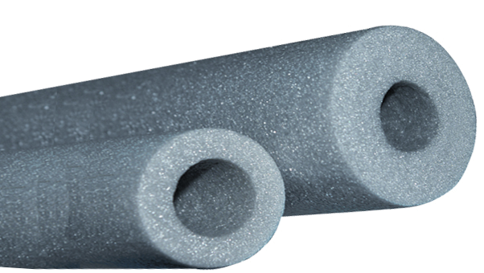 | 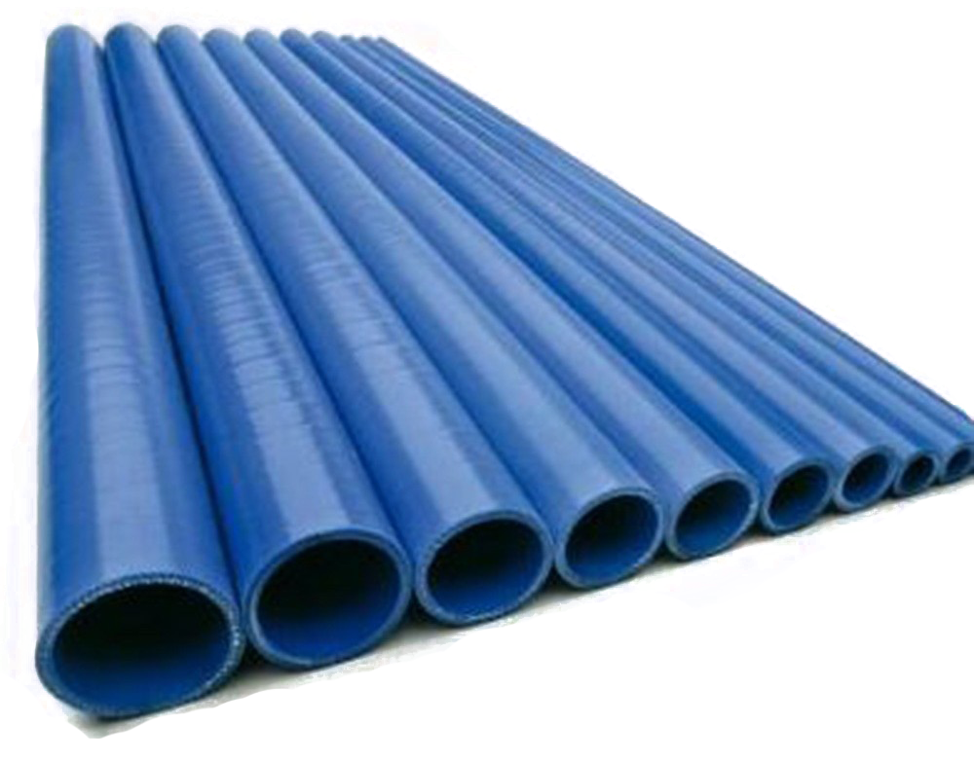
Adequate protection | Inadequate protection

The chassis must have a plate that functions as a base and that must be firmly fixed to the chassis, preventing any part of the driver from touching the ground in any circumstances. In addition, it must be sufficiently rigid so as not to deform under the weight of the driver. The maximum deformation allowed will be 5 mm in circumstances of normal use: getting in and out of the single-seater vehicle, resting the feet in the area of ​​the pedals, etc. The base must have a hole that allows liquids to drain away.
Designs with sharp or cutting edges without protection, which may pose a danger to a participant of the trial, administrator and/or member of the public, will not be accepted under any circumstances.
The inclusion of any loose item inside the vehicle is not permitted.
The structure of the vehicle must be strong enough to withstand the stresses to which it will be subjected during the competition.
All types of protection added are acceptable, both to protect the chassis from possible incidents and to protect the bodywork.
In case of doubt about the safety of the chassis presented, the organisation may demand the modification or deny the use of the chassis in question for participation in the competition.

Roll bar
The driver’s compartment must be equipped with at least two roll bars. The roll bars must be made of the following materials or better:
Material | Profile | Minimum yield stress | Side/outside diameter |  | Thickness
Aluminium | Round | 150 MPa | > 35 mm | > 3 mm
Steel | Round | 250 MPa | > 30 mm | > 2mm
Aluminium | Square | 150 MPa | > 35 mm | > 3 mm
Steel | Square | 250 MPa | > 30 mm | > 2 mm

In the case of designing a roll bar with other materials, this must be included in the submission of the concept to be validated by the organisation. The safety of the chosen roll bar must be adequately justified. In addition, special care must be taken when welding the roll bar, and roll bars with welds of doubtful strength will not be permitted.
The rear roll bar must be located at a distance of less than 150 mm immediately behind the driver. This must be at least as wide as the full width of the shoulders and must stop the head passing beyond it by means of a headrest that must be part of the chassis and extend a minimum of 100 mm above the upper edge of the driver’s helmet in the normal driving position. In addition, it must be vertical or inclined towards the rear by no more than 10° and extend below the lowest part of the driver. This rear roll bar must have two reinforcements towards the rear of the monocoque. The support of these reinforcements must be a minimum of 80 mm behind the roll bar and reach to at least 65% of the height of the roll bar. Regarding the configuration of these reinforcements, two alternatives shown in the following image are permitted:
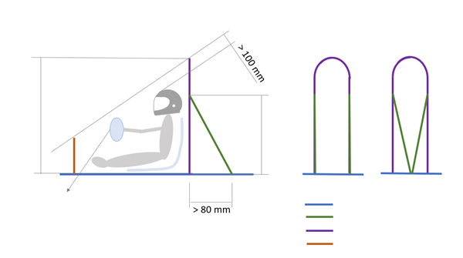
Steering wheel below imaginary line
Chassis
Reinforcement
Roll bar
Front roll bar
Alternative 2
Alternative 1
Rear view
Side view
Roll bar height
> 65% roll bar height
The second safety roll bar must be located in the front part in such a way that the imaginary line between the two of them does not allow the helmet to get closer than 100 mm from the ground in the event of the vehicle turning over. The steering wheel is also not allowed to leave the line between the two roll bars in any position (turned and straight). An additional coupling to the roll bar may be included to increase its height as long as its maximum interior height is 200 mm and its maximum interior width is 100 mm.
The roll bar must comply with the requirements for structure and minimum dimensions indicated in the following image:
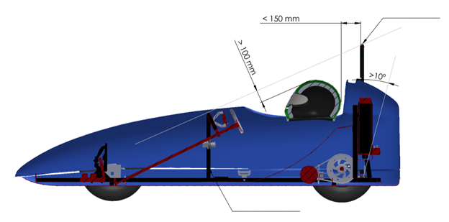
Rear roll bar
Front roll bar
<
The roll bar can be installed by either welding or bolting to the chassis. Any bolts used must be M8 or larger and the quality 8.8 or higher. The front and rear roll bars must be connected by a sufficiently strong structure so that, in the event of an accident, the driver’s compartment remains unaltered.

Materials
The use of any construction material is accepted as long as it satisfies all of the requirements indicated in section 4.2.1 or 4.2.2 of these rules. Therefore, and in order to promote innovation and emerging manufacturing techniques, materials such as steel alloys, aluminium alloys, titanium alloys, magnesium, ceramic materials, carbon fibre composites or aramid fibre etc. are allowed.
The wheel axles must be made of steel and must be firmly fixed to the chassis without the possibility of bending. It is not permitted to attach any axle by means of bearings that allow their lateral displacement.

Driver’s compartment
The driver’s seat can be of the kart type or similar and will be firmly fixed to the chassis structure and the vehicle’s roll bar.
The driver’s backrest must have a minimum angle of 20 degrees with respect to the vertical towards the rear of the vehicle.
The component indicator display and EUS20 display wiring must be located in the driver’s compartment and must be visible to the driver and accessible to the organisation at any time.

Steering, traction and brakes

Steering
Although there are no restrictions on the type of steering to be used (rack and pinion, chain, direct, etc.), this must be firmly attached and must not present appreciable bending of any kind (torsion in the column, bending of the steering linkage, when reaching the stops, etc.). The steering wheel must have a mechanical connection with the drive wheels. The use of cable connections is not allowed. The steering assembly must be designed to have a minimum turning radius of 3.5 metres to both sides, taking as a reference the centre of the inner wheel of the vehicle as specified in section 4.7.3 of the rules.
The steering system must be designed to avoid any contact between the tyre and the body or chassis by means of a mechanical stop.
The steering wheel may be fixed or removable, but in either case its firmness must be guaranteed and it must be attached to the steering axle. The steering wheel must be operated with both hands at the same time with a turning movement.
Handlebars, levers, steering bars, joysticks, indirect or electrical systems are not allowed.

Wheels
All vehicles must have four identical wheels (combination of rim and tyre), with rims up to 10” and with a diameter of the entire wheel of between 390 and 450 mm. The tyres must be models commercially available for road use, smooth or with a pattern, but never with studs. Traditional tube or tubeless tyres are acceptable. Bicycle tyres are prohibited.
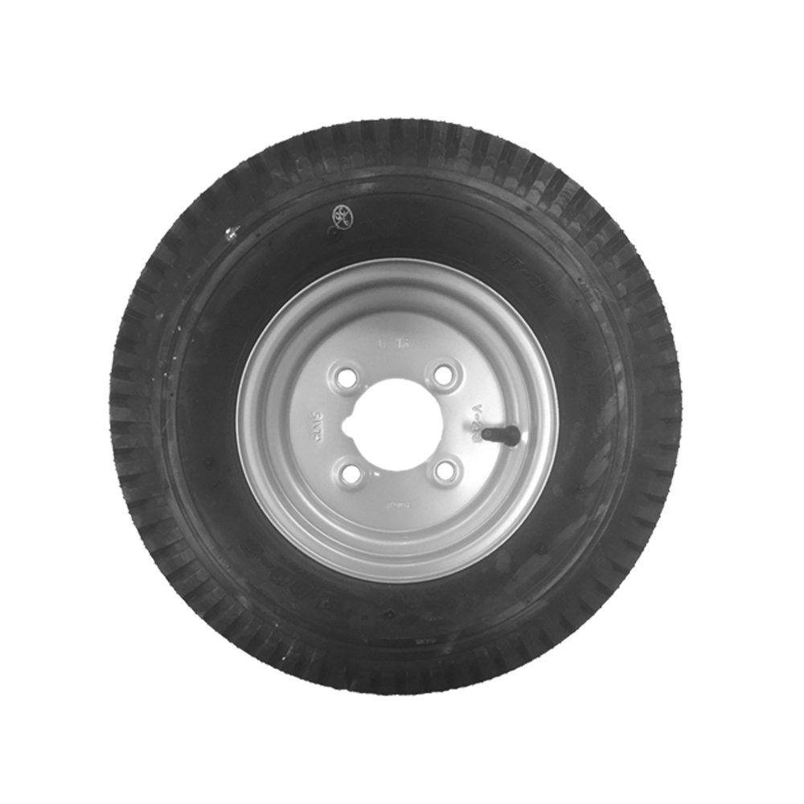
It is mandatory to ensure the minimum pressure indicated by the manufacturer in each case. The maximum tyre pressure permitted will be the lower of 4.9 bar or the maximum pressure allowed for the tyre. The organisation has the right to check the tyre pressure at any time during the championship.

Motor and transmission
The only motor and motor controller permitted will be those supplied by the organisation and none of their components may be opened or modified.
All the power wiring of the traction battery and the electric motor must have an orange exterior colour, and this wiring cannot be modified without express authorisation from the organisation, and it cannot be wrapped with tape or covers that are not intended for this purpose.
The location of the motor and controller should allow easy verification of the organisation’s inspection seal. The use of any system of transmission to the drive wheels is permitted.
The drive train (pinion, crown, chain) must be protected so that at no time is it possible for the fingers, hair or clothing of the driver or anyone near the car to come into contact with them and get caught in the system. This will be checked with a 15 mm diameter bar (approximately the size of a finger) and it should not be possible to make contact with any part of the drive train with the guard fitted. This guard can be removable for adjustment, maintenance and verification work.

Additionally, the driver must be protected from chains or belts by means of a steel plate of at least 1 mm or an aluminium plate of at least 2 mm. It must not be possible for the chain or belt to reach the driver without being intercepted by this sheet metal guard.

Accelerator
The use of the EUS20 accelerator pedal is mandatory, unless expressly authorised by the organisation, and it should be remembered that as part of the power kit it is completely forbidden to dismantle or modify it.

Brakes
The vehicles must have a mechanical or hydraulic brake system that will act on all four wheels simultaneously and with a single command. It is mandatory that the braking system be double and although it requires a single activation, the front system must be independent from the rear, so that in the event of a failure in one axle the other continues to function. Crossover systems will also be permitted (front left wheel with rear right and front right with left rear). No electrical intervention of any kind will be permitted in the brakes (ABS systems, braking assistance, etc.).
The driver must be able to operate the brakes without taking his/her hands off the wheel.
The braking system must have the ability to completely stop the vehicle travelling at a speed of 20 km/h, maintaining direction, in a distance no greater than 8 metres.
It is mandatory to signal the braking action with a red light. This signalling must be well visible in daylight and must be carried out using at least one indicator light, in the rear, visible to the other drivers in the championship.

Electrical system

Specification of the electrical components
The vehicle’s propulsion system must be easily accessible in its entirety for carrying out tasks of inspection and measures to verify the electrical components.
The vehicle will have at least the following electrical installations:
- The electric traction system will essentially consist of:
  - EUS21 three-phase permanent magnet motor
  - Guilera EUS21 motor controller
  - Alterity EUS20 lithium battery
  - EUS20 drive contactor
  - EUS20 complete accelerator pedal
  - Alterity EUS20 electrical connector harness manufacturing kit
  - EUS20 display indicator and display wiring
  - EUS20 manual maintenance switch
These components are supplied by the organisation and no drive system, energy supply or supplementary accumulation is allowed in the traction system.
The use of all the components provided by the organisation is mandatory unless expressly authorised.

- Auxiliary electrical system:
This system can be powered through a nominal 12 V DC auxiliary accumulator as provided in point 4.4.2 or by using the 12 V 3A max. DC/DC converter, which incorporates the controller, as specified in the Euskelec 2021 electrical diagram.

It is mandatory to provide the following components:
  - At least one rear position light, according to point 4.6.9, which must be on whenever the vehicle is running.
  - At least one rear brake light according to point 4.6.9.
  - Horn according to point 4.6.5.
All push-buttons, switches and/or controls must be accessible by the driver with the seat belt fastened.
The rest of the electrical and/or electronic components installed in the vehicle in this system or others must be represented in the diagram.
All components must be correctly attached to the bodywork and/or chassis of the vehicle, avoiding the use of plastic ties. They must be accessible and electrically verifiable without being dismantled.
Vehicle wiring must be protected, secured and correctly guided. It must be fitted in the driver’s compartment and exposed connections (stripped cables, wired outside the vehicle, unprotected connections, etc.) must be avoided at all times.
All electrical installations must be accessible. They can be covered by removable covers. During verification it will be necessary to remove these.
The use of terminal protectors will be required in all the connectors or terminals of the motor and battery, fitted in the controller.
It is not permitted to use the chassis as a conductive component of any of the vehicle’s electrical circuits, either positive or negative.
The use of a digital type voltmeter, ammeter and speedometer with their own power is permitted. They must be firmly fixed to the structure or dashboard and their batteries must not exceed a power of 50 Wh and 14 V.
The vehicle’s electrical system is required to be suitable for wet weather conditions in order to avoid malfunctions.

Electric accumulators
Vehicles must have the following accumulation systems:
Compulsory:
- Traction system accumulator:
It will be mandatory to use the battery provided by the organisation and no supplementary or alternative energy storage system may be connected to this.
The manipulation of the accumulator of the traction system, as well as the extraction of energy from it, outside the traction and control circuit proposed in the Euskelec power kit is completely prohibited.
It must be possible to extract the battery quickly, and the organisation can request its extraction at any time.
The use of the battery charger supplied in the kit is mandatory. This accumulator can never be charged with a different charger or modified. The organisation can request the checking of this component at any time.
All the power wiring of the traction battery and the electric motor must have an orange exterior colour, and this wiring cannot be modified without express authorisation from the organisation, and it cannot be wrapped with tape or covers that are not intended for this purpose.
Optional:
- Auxiliary accumulator, in which any energy storage system can be used, in order to operate the vehicle’s auxiliary services (position light, brake light, horn etc., as appropriate), but never to recharge the traction system and/or the main accumulator. This accumulator will have a nominal voltage of 12 V DC and must not exceed 15 V DC at any time. If it is decided to use this system, it must be protected against overloads according to point 4.4.3.
- Some devices can be powered by batteries other than propulsion or auxiliary batteries, as long as they use internal batteries. This equipment may be: Radio communication systems, data acquisition and/or monitoring systems. The use of these systems is subject to specific approval by the organisation following the submission of the electrical diagram.
Team members who handle batteries must wear gloves and specific protective glasses for this purpose.

Electrical protective devices
The Euskelec power kit already has the devices to protect against short circuits and overloads appropriate for its use for competition. These cannot be manipulated in any way or removed.
Every electrical system in the vehicle must be protected against short circuits. This protection can be by means of a fuse or a thermal magnetic switch. Devices with automatic reset are prohibited.
The short circuit protection has to be located on the positive conductor and as close as possible to the batteries. The operating range of the protective device must be chosen so that the fuse is capable of isolating the short-circuit current necessary to open the device at any time.
Every electrical system in the vehicle has to be protected against overloads, either by using electrical controllers to keep current levels within established limits or by calibrated fuses.
The traction battery must have both positive and negative conductors, electrically isolated from the vehicle chassis and the auxiliary accumulator circuit.
All electrical boxes, or at least their covers, with simple dismantling must show the circuits and the components of which they are composed so that the circuits can be followed. The range of action of the protective device must be chosen so that the battery is capable of supplying the short-circuit current necessary to open the device at any time (and the selection of the fuse must be adapted to the circuit in order to protect it, and the fuse must be disconnectable by the accumulator current).
The cross section of the wiring must be sufficient to conduct at least the current for which the corresponding circuit has been designed. In the case of the power circuit, both in the DC stage and for the three-phase alternating current stage, the minimum section will be 10 AWG or 6${mm}^{2}$ gauge copper for each conductor.

Maintenance switch
This component is supplied with the power kit and must be used to guarantee there is no voltage present in the vehicle before carrying out any work on it. More details about its installation are given in point 4.6.8.

Bodywork

Design
The use of bodywork is mandatory. This must have a minimum height of 200 mm along its entire length from the edge of the chassis base and must cover both the front and the sides of the vehicle. If the bodywork is closed, it must be possible to open the driver’s compartment both from the inside and from the outside. The bodywork must be such that the wiring and the entire power train system can always be accessed.
The bodywork must be of solid construction and firmly secured to the chassis. It can be of one or more pieces. However, it must be easily removable in case checking or verification of the components provided by the organisation is required.
In order to provide room for both the mandatory championship stickers and the identification of the centre, the vehicle numbers allocated and the technical verifications of the championship, a surface area of ​​15x21 cm (A5 horizontally) will be reserved at the front, 15x21 cm on each side of the vehicle and 15x21 cm at the rear of the vehicle. Team numbers must be visible from both the sides and the front of the vehicle. They will be provided by the organisation on the day of the event.
All the mechanical elements, motors, bolts, chains, wheels and batteries must be kept out of the driver’s reach from the cockpit. There should be no line of sight between any mechanical component of the transmission and the driver.
The bodywork must allow the driver to have a visibility with a minimum amplitude of 180° and the correct evacuation of the driver according to section 4.6.2.
Bodywork designs with sharp or potentially cutting forms that could pose a danger to other participants are not permitted. For safety reasons, all edges and finishes of the body must be rounded with a minimum radius of 10 mm both on the outside and inside of the bodywork.
Vehicle bodies with any external attachment that could be dangerous to anyone will not be accepted. Sharp points in the exterior design of the vehicle must be avoided. Alternatively, if the above standard cannot be met, the sharp points must be covered with foam or a similar deformable material, to avoid causing damage in the event of a collision.
There are no restrictions on the shape of the bodywork or the materials used for its manufacture, although vehicles with aerodynamic bodywork, with smooth curves and appropriate proportions will be positively rated.

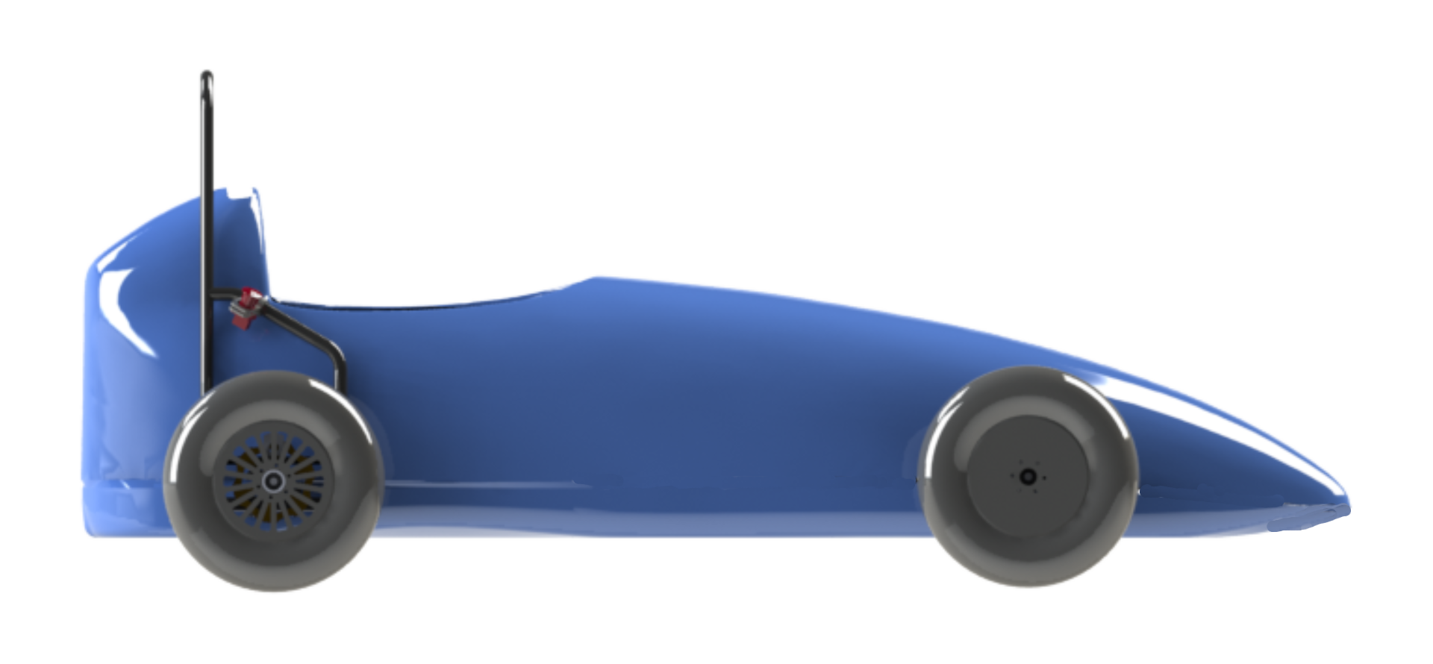

Team numbers
Each vehicle must include 3 identifying numbers on the bodywork, one being on one side of the vehicle, another on the front of the vehicle and another on the rear. They will be handed out by the competition
The vehicle or team number will be awarded in order of position in the previous edition of the championship and in order of registration in the event the team has not participated previously.

Identification
In all prototypes the name and logo of the centre which it represents must be shown. The logo or the initials of the centre must occupy an area with a minimum height and width of 120 mm.
There should be a space on the chassis for the technical verification stickers. Any identifying element of the components supplied by the organisation may not be covered with paint or adhesive foil.

Advertising
It is strictly forbidden to include advertising of alcoholic beverages or tobacco on the vehicle or in any other type of corporate media used by the team.
It is strictly forbidden to include advertising or other types of message that are offensive to human dignity (violence, intolerance, xenophobia, racism, etc.) or that may offend the sensibility of certain people, both in the vehicle and in any other type of corporate media used by the team. The organisation also reserves the right to review and analyse the advertising content and prohibit this if it finds it appropriate.

Ventilation of the cockpit
The vehicles must be designed taking into account the temperatures that can occur in the interior during the championship sessions. To avoid the driver’s discomfort, the cockpit (in the event that it is closed) must be properly ventilated. The use of forced ventilation is permitted for this purpose and must be connected to the auxiliary components circuit with an auxiliary accumulator.

Safety equipment

Seat belt
The vehicle must have a seat belt with at least 4 anchor points to keep the driver in his/her seat in the event of an accident. The seat belt must be manufactured specifically for motor sport use (for example, certified or compliant with FIA standards) and under no circumstances is it permitted to tamper with it. This must prevent any upward or forward movement of the driver’s torso. Any slack in the belt harness must be adjusted using the device’s length adjuster. The regulator should be located as close as possible to the connection point.
When the belt is fastened, the belt mechanism must be in the soft part of the thorax (the navel), over the waist and never over the ribs and/or hips; that is, it must be in the navel area.
The 4 independent straps must be firmly attached to the main structure of the vehicle as indicated in the following photograph and respecting the dimensions shown:

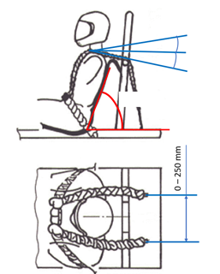
70° max.
20° max.
10° max.
The safety harness must always be worn tight and fastened, to prevent the driver from being able to move freely when the vehicle is in motion.
The safety harness must be able to support a minimum load of 70 kg in each of its anchor points.

Evacuation of the driver
The driver must be able to leave the vehicle at any time, and without help, in less than 12 seconds, without dismantling the bodywork. The driving position must also allow simple evacuation of the driver by the emergency services if necessary.

Towing points
It will be mandatory to have a front attachment point and a rear attachment point, both clearly visible. These elements must be capable of supporting the towing of the vehicle itself or they must be capable of supporting a load of 2.5 kN. Examples of suitable attachments or eyes that can be used as towing points are shown below:
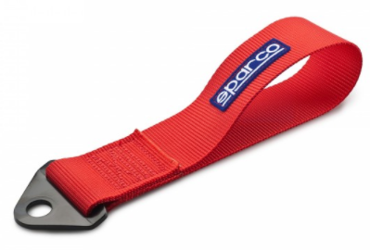
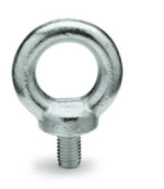

In the event that the eye protrudes from the front of the vehicle and may pose a danger, it must be dismantled to carry out the dynamic tests. The eye must remain in the box ready to be used if necessary.

Insulation of the traction system
There must be a fixed, rigid and resistant wall that separates the driver’s compartment from the traction system: motor, motor controller, battery and their corresponding connections and other devices that exceed a voltage of 15 V. The fitting of batteries inside the driver’s compartment is not permitted. There will be no unprotected conductors with a voltage greater than 15 V within the driver’s compartment.

Horn
Each vehicle must be equipped with an electric horn, mounted on the front of the vehicle, which is audible by drivers, other vehicles and track marshals, with a minimum level of 80 dBA, measured with a horizontal separation of 2 metres from the vehicle and 1 metre away in a direction perpendicular to the ground. It must be operable by the driver using a push-button.

Speedometer
Although the use of a speedometer is not mandatory, it is highly recommended, so that the driver is aware of the speed.
The speedometer configuration must take into account the construction of the vehicle, including the outer diameter of the wheels used.

Emergency stop
This circuit must have 3 interlocking rotary type switches to actuate the emergency stop. These will act on the motor controller and the battery. There must be at least one switch visible from any angle when a steward approaches the vehicle. If necessary, additional switches may be included.
The 3 switches must be firmly attached. Two emergency stop switches will be located one on each side of the vehicle, accessible from the outside, with a minimum diameter of 40 mm. A third emergency stop will be located in the cockpit and accessible from the normal driving position, with the seat belt fastened. The minimum diameter of the cockpit switch will be 24 mm. The propulsion of the vehicle must be stopped by pressing one button, two or all three simultaneously, or any combination of these, and without requiring any other commands in this manoeuvre.

The emergency switches must electrically disconnect the propulsion battery from the vehicle’s electrical system or feed the stop system. It is mandatory to follow the connection indicated in the Euskelec 2021 electrical diagram to guarantee the success of the manoeuvre while the vehicle is running. Examples of valid switches are given below:
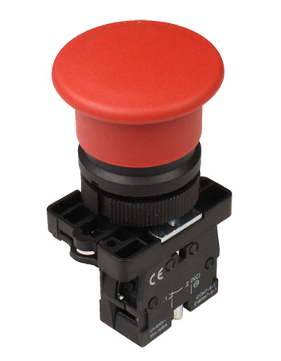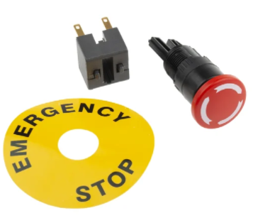

Maintenance stop
A maintenance shutdown system must be installed on the vehicle. This must be placed between the traction battery and the motor controller, firmly fixed and allowing the switch to be actuated without removing any component from the vehicle.
The maintenance switch must have a removable key to guarantee there is no voltage present at any time until the work on the vehicle has been completed. If the key is out of the switch, the circuit is open. After the work has been completed, the key will be activated again, closing the circuit.
Each team must be aware of the disconnection protocol for their vehicle in accordance with challenge 5 Electrical diagram since a maintenance shutdown may be required at any time.
The maintenance switch must guarantee the electrical isolation of the positive conductor independently of the position or situation of the controls, push-buttons or switches.

Position and brake lights
It will be mandatory to have at least 1 light at the rear of the vehicle, called the position light. The component must have a red light, and when the light is on it must be visible at a distance of 50 m in broad daylight. This component will be used to increase the mutual visibility of participants.
It is mandatory to have at least 1 brake light which can be shared with the position light. This must be located at the rear of the vehicle. It must be activated with a push-button and a fixed light must turn on when the brake pedal is actuated, no matter how gentle the operation of the brake pedal. The intensity of the light must be greater than that of the position light and it must be possible to distinguish it from the position light at a distance of 50 m in broad daylight.
The brake light actuation cannot interfere with the controller system and must be independent of the Guilera EUS21 controller actuation sensor.

Vehicle verification
Prior to each event that takes place in the circuit, a technical verification will be carried out on all vehicles to ensure that they meet all the requirements described in the section of the technical and vehicle safety rules. It is essential that a technical panel always validates the vehicle before it has access to the track, either for practice or competition.
These checks will be carried out by a technical panel belonging to the organisation. They will involve a review of the vehicles based on the following checklist and will declare the vehicles either suitable or not suitable for participation in the championship.
More specifically, the following aspects of the vehicle will be checked:
- The dimensions of the vehicle and the total weight of the vehicle with driver and equipment.
- The incorporation of all the mandatory mechanical elements such as roll bars, mirrors, covers, numbers, etc. and the correct operation of these.
- The braking system.
- The steering system.
- The fastening of the seat belt.
- The tyre pressure.
- The isolation of the wheels and the propulsion system from the driver.
- The visibility of the driver in the normal driving position.
- The correct operation of all the emergency stop and maintenance system actuators, both with the vehicle running and before starting it.
- The electrical system of the vehicle (components, connections, wiring, securing of components, etc.)
- Visual signalling of braking.
- The deactivation of the accelerator signal when the brake pedal is activated will be verified. The controller automatically deactivates the motor when the brake pedal is pressed, so fitting a brake sensor and connecting it correctly to the controller will be sufficient.
- Verification of safety marking, stickers and seals.
- Verification of compliance with the minimum turning radius.
- Evacuation of the driver.
This verification will NOT be scored and will serve to verify that the vehicles meet the technical minimum requirements of the competition.

Verification of driver evacuation
The driver must be able to leave the vehicle at any time and without help in less than 12 seconds, without operating any doors or moving panels. The driving position must also allow simple evacuation of the driver by the emergency services if necessary.
This verification will simulate an emergency evacuation and will be timed by a judge from the organisation. The driver will have three attempts in which the judge will check that the driver is capable of leaving the vehicle in a maximum time of 12 seconds. If a driver does not pass this test, he/she will not be able to participate in the competition.

Verification of braking
The braking trial will be carried out to ensure the proper functioning of the braking system and it is essential to pass it in order to participate in the dynamic tests.
Vehicles will have to brake completely within the distances specified below:

- Dry track: The vehicle will have to brake completely within a maximum distance of 8 metres at a minimum speed of 20km/h on a 2.5 metre wide track.
- Wet track: In the event of adverse weather conditions that may affect the asphalt and/or the driving of the vehicles, the organisation reserves the right to modify or cancel this verification by virtue of the safety of drivers and assistants.
In the event that the vehicle was not capable of reaching the indicated speed of 20km/h, the maximum allowed braking distance would be calculated as a function of speed, according to the following table:
Speed (km/h) | Allowable braking distance (m)
19 | 7.6
18 | 7.2
17 | 6.8
16 | 6.4
15 | 6

A vehicle that exceeds the maximum braking distance, regardless of the speed at which it performs the test, crosses over the lines that delimit the track or that the judges determine has braked before reaching the braking line, will not have passed the test and will have to repeat it. No maximum number of opportunities is specified. If a team does not pass the test, it will be able to make the necessary adjustments and will reposition itself behind the last team that is waiting to take the test. The maximum duration of the test will be limited to the time that the organisation stipulates for the technical verification.

Verification of the turning radius
In this test, the vehicles must be able to describe a minimum turning radius of 3.5 m to both sides, taking as a reference the centre of the inner wheel of the vehicle.
The vehicle being verified will be eligible if it manages to follow the layout of the track without going beyond its boundaries or knocking over any cones. Otherwise, the vehicle will fail the test. No maximum number of opportunities is specified. If a team does not pass the test, it will be able to make the necessary adjustments and will reposition itself behind the last team that is waiting to take the test. The maximum duration of the test will be limited to the time that the organisation stipulates for the technical verification.

Right of inspection
The organisation reserves the right to inspect any team at any time during the championship if it considers that the vehicle presented does not comply with the technical rules or represents a risk for the participants, the public and/or the organisers.
Additional inspections will be carried out if, after passing the technical inspection with a favourable result, important parts of the vehicle, such as the motor, battery, controller, brakes or other elements that may affect the driver’s safety, have been replaced. In this case, the vehicle will have to be re-approved by the organisation.
The organisation can carry out unannounced inspections at any time.

Rectification of problems or adjustments
The teams will be able to carry out the activities to repair, adjust or modify the vehicles in the waiting time between verifications or between the tests. These times will be set by the organisation of the championship and the teams will be informed before the day of the event, but they may be modified during the course of the event due to unforeseen events or delays on the day itself. The teams can modify any aspect of the vehicle as long as they adhere to these rules and the championship times. The organisation reserves the right to carry out checks at any time to ensure the compliance of the different adjustments with the rules. The teams have the responsibility to arrive on time at the start of the tests, and may lose the opportunity to compete in the test in question and, therefore, also to score points if they do not arrive at the start on time. It will not be possible to modify the structural chassis of the vehicle or the height of the vehicle with respect to the ground without authorisation from the competition (in the event of repairs), but it will be permitted to make the following types of adjustment between tests: brake distribution, angle of aerodynamic elements, pressure of tyres, stiffness of shock absorbers or stabilisers, change of transmission crown wheel, etc.
All repair, adjustment or modification operations must be carried out within the box area of ​​each team and in no case may anyone outside the championship manipulate the vehicle.

Rules of the event

Event guide
All the information regarding the carrying out of phase 1 and 2 of the championship is provided in the “Event guide” where the location, distribution and timetables of the different phases of the championship are detailed. In case of conflict or discrepancy between the “Event guide” document and these rules, these rules will prevail.

Complaint form
To make a complain to the organisation or challenge another team, the following form must be completed:
https://forms.gle/gmrDVY2zzdPZpMTF6
Additional information should be sent to admin@euskelec.eus to provide photographs or more extensive explanations if necessary.
The organisation will automatically receive a notification each time the form is filled in and will try to respond as quickly as possible.

Enquiry form
To make an enquiry about the rules, the following form must be completed:
https://forms.gle/Mu1CzJwkNk1JAD4Q7
Additional information should be sent to admin@euskelec.eus to provide photographs or more extensive explanations if necessary.
The organisation will automatically receive a notification each time the form is filled in and will try to respond as quickly as possible. In addition, in the website www.euskelec.eus the teams will be able to find assistance in the form of technical documents, training and a contact form.

