5th Championship of the Basque Country

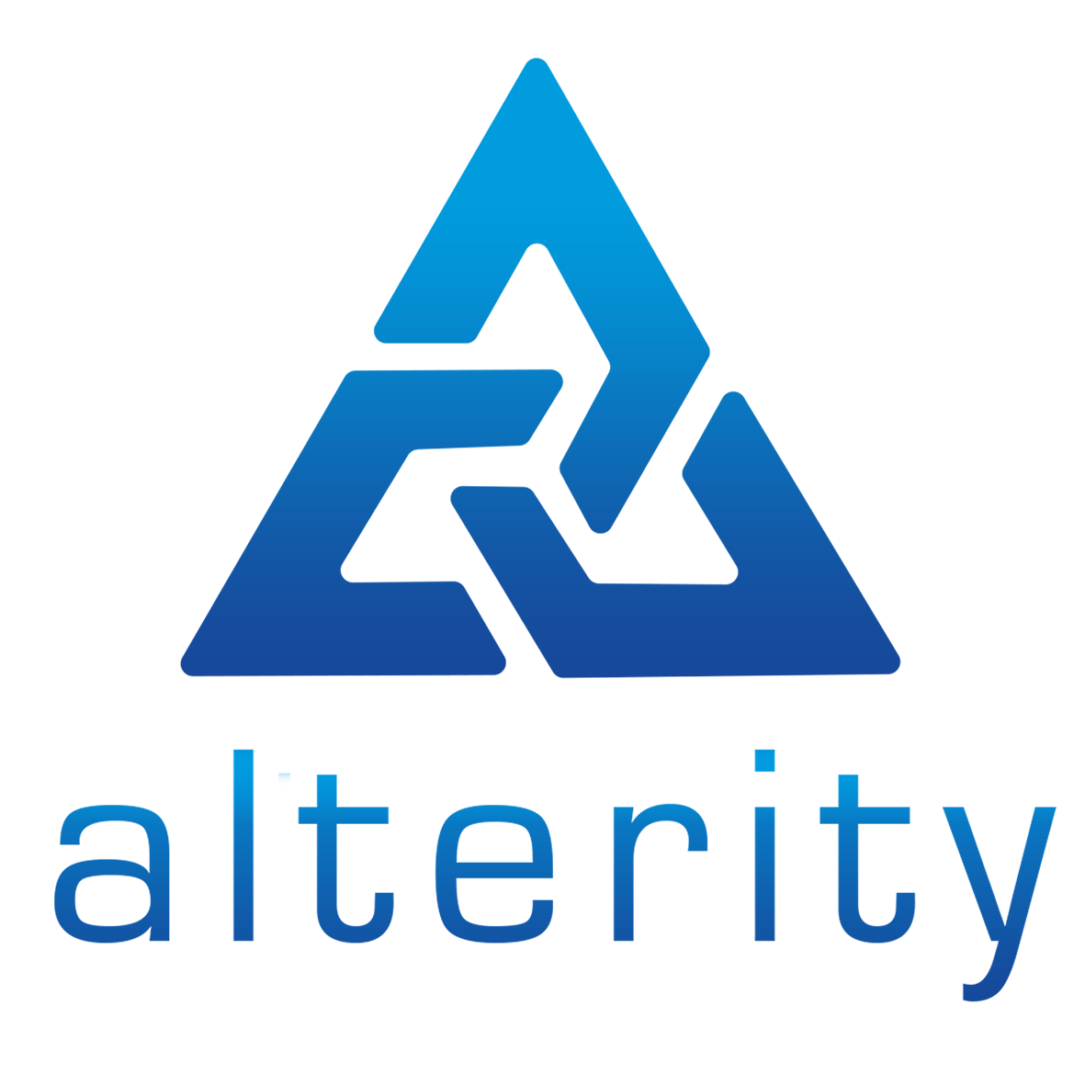
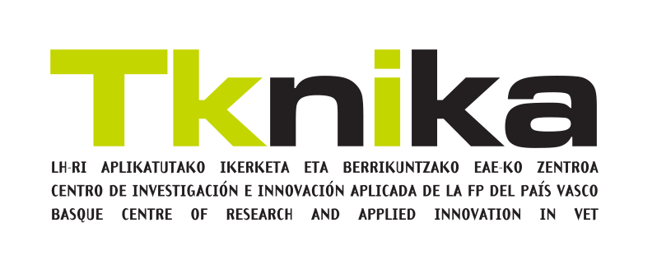
Calendar

Ref. 09-2021

calendar
The complete calendar for the 5th edition of Euskelec is as follows:
Task | Sep-21 | Oct-21 | Nov-21 | Dec-21 | Jan-22 | Feb-22 | Mar-22 | Apr-22 | May-22
Registration: | 15-Sep
Training |  |  |  | December
Team details |  | 29-Oct
Analysis of the competition |  |  | 26-Nov
Communication |  |  |  | 17-Dec
Concept |  |  |  |  | 28-Jan
Electrical diagram |  |  |  |  |  | 25-Feb
Innovation |  |  |  |  |  |  | 25-Mar
Report |  |  |  |  |  |  |  | 29-Apr
Presentation Phase 1 + Verification |  |  |  |  |  |  |  |  | May
Phase 2 |  |  |  |  |  |  |  |  | May

Remarks:
- The December training, phase 1 submissions, verification and phase 2 do not have the dates specified. They will be specified during the year.
- For each challenge, a Word template will be provided that must be used. This template and the rest of the necessary information will be sent to each centre by email.
- The dates indicated for the challenges are deadlines. This means that the challenges must be submitted no later than the indicated day, but can be submitted earlier if desired.

